**COURSE OUTCOME & PROGRAM OUTCOME**

**ATTAINMENT CALCULATION**

**A Project Report**

*Submitted By*

**AJITH P (714019205004)**

**KARPAGAMAINTHAN M (714019205023)**

**NAVEEN E (714019205031)**

*in*

*Partial fulfillment for the award of the degree*

*of*

BACHELOR OF TECHNOLOGY



**DEPARTMENT OF INFORMATION TECHNOLOGY**

**SRI SHAKTHI INSTITUTE OF ENGINEERING AND TECHNOLOGY**

**L&T BYPASS ROAD, CHINNIYAMPALAYAM COIMBATORE– 640 062**

**TAMIL NADU, INDIA**

**DECEMBER 2022**

**SRI SHAKTHI INSTITUTE OF ENGINEERING AND TECHNOLOGY L&T**

**BYPASS ROAD, CHINNIYAMPALAYAM COIMBATORE– 640 062**

**BONAFIDE CERTIFICATE**

This is certified that title “ **COURSE OUTCOME & PROGRAM OUTCOME ATTAINMENT CALCULATION** ” is bonafide work of  **AJITH P (714019205004), KARPAGAMAINTHAN M (714019205023), NAVEEN E (714019205031)** who carried out the research under my supervision.

|  |  |
| --- | --- |
| **SIGNATURE** | **SIGNATURE** |
| **Dr.S.Prakash** | **Dr.S.Prakash** |
| **SUPERVISOR** | **HEAD OF THE DEPARTMENT** |
| **Dept. of Information Technology** | **Dept. of Information Technology** |
| **Sri Shakthi Institute of Engineering** | **Sri Shakthi Institute of Engineering** |
| **and Technology, Coimbatore** | **and Technology, Coimbatore** |

|  |  |
| --- | --- |
| **INTERNAL EXAMINER** | **EXTERNAL EXAMINER** |

# TABLE OF CONTENT

|  |  |  |
| --- | --- | --- |
| **SNO** | **CONTENT** | **PAGE NO** |
|  | **ABSTRACT** | **I** |
|  | **LIST OF FIGURES** | **II** |
|  | **LIST OF ABBREVATION** | **III** |
| **1** | **INTRODUCTION** | **8** |
|  | **1.1 EXISTING SYSTEM** | **8** |
|  | **1.2 PROPOSED SYSTEM** | **8** |
| **2** | **OBJECTIVE** | **9** |
| **3** | **REQUIREMENT** | **10** |
|  | **3.1 FUNCTIONAL REQUIREMENTS** | **10** |
|  | **3.2 NON-FUNCTIONAL REQUIREMENTS** | **10** |
|  | **3.2.1 SOFTWARE REQUIREMENTS** | **10** |
|  | **3.2.2 HARDWAREREQUIREMENTS** | **10** |
| **4** | **SYSTEM REQUIREMENT** | **11** |
|  | **4.1 TOMCAT** | **11** |
|  | **4.2 MYSQL** | **11** |
| **5** | **SYSTEM ARCHITECTURE** | **12** |
| **6** | **IMPLEMENTATION OF THE SYSTEM** | **13** |
|  | **6.1 STEPS** | **13** |
|  | **6.2 SOFTWARE IMPLEMENTATION** | **13** |
|  | **6.2.1 XAMPP APP** | **13** |
| **7** | **DESIGN AND IMPLEMENTATION** | **15** |
|  | **7.1 Product features** | **15** |
|  | **7.2 Modules** | **15** |
|  | **7.2.1 Admin** | **15** |
|  | **7.2.2 Faculty** | **15** |
|  | **7.2.3 Student** | **15** |
|  | **7.2.4 Parents and Alumni** | **15** |
|  | **7.3 Database** | **16** |
| **8** | **CALCULATING PROCESS** | **17** |
| **9** | **RESULT** | **24** |
| **10** | **CONCLUSION** | **25** |
|  | **10.1 FUTURE ENCHANCEMENT** | **25** |
| **11** | **REFERENCES** | **26** |
| **12** | **APPENDICES** | **27** |

**ABSTRACT**

The course outcome & program outcome attainment calculation system is a set of tools that enables the teaching staff to create student batch and enter their exam scores on the Web in order to calculate attainment. It enables the college or university to provide individual user account to each faculty. All the user accounts (Admin and teaching faculty) are password protected. So, the database can be termed as secured.

In CO & PO Attainment Calculation Portal , only administrative section is allowed to create the account, but faculty can register with application. After creating the account, the user can view his/her detail by using SQL query.

In the existing system, we can store all the record manually in spreadsheets that require large manpower & place to store all the records but it does require only a database connectivity to store all the data. It can handle all details about a college mark sheet system. The details include faculty details, subject details, student personnel details, academic details, exam details. In this we can implement a facility that a faculty can be able to create a new batch of students and other faculties those who have mapped to handle subjects, can able to access and enter marks of that batch students.

In this CO & PO Attainment Calculation Portal there are two modules like administrator and faculty. Admin can produce accounts for college .Faculty can create batch and gives access to their respective semester faculties to enter students marks.

# LIST OF FIGURES

|  |  |  |
| --- | --- | --- |
| **FIG.NO** | **NAME** | **PAGE.NO** |
| **1** | **CLIENT SERVER ARCHITECTURE** | **12** |
| **2** | **XAMPP CONTROL PANEL** | **14** |
| **3** | **MARK TABLE** | **16** |
| **4** | **STUDENT TABLE** | **16** |
| **5** | **FACULTY TABLE** | **16** |
| **6** | **ASSESSMENT CYCLE** | **17** |
| **7** | **DEFINE COURSE OUTCOME** | **17** |
| **8** | **FINAL CO ATTAINMENT CALCULATION** | **19** |
| **9** | **FINAL PO ATTAINMENT CALCULATION** | **22** |
| **10** | **PO HOME PAGE** | **27** |
| **11** | **SUBJECT HOME PAGE** | **27** |
| **12** | **COURSE OUTCOME PAGE** | **28** |
| **13** | **INTERNAL MARK SHEETPAGE** | **28** |
| **14** | **FINAL CO ATTAINMENT CALCULATION** | **29** |

**LIST OF ABBREVATIONS**

|  |  |
| --- | --- |
| **HTML** | **HYPER TEXT MARKUP LANGUAGE** |
| **JS** | **JAVASCRIPT** |
| **XML** | **EXTENSIBLE MARKUP LANGUAGE** |
| **JDBC** | **JAVA DATABASE CONNECTIVITY** |
| **CSS** | **CASCADING STYLE SHEETS** |
| **HTTP** | **HYPERTEXT TRANSFER PROTOCOL** |
| **RAM** | **RANDOM ACCESS MEMORY** |
| **JSP** | **JAVA SERVER PAGES** |

# CHAPTER – 1 INTRODUCTION

The CO & PO attainment calculation system is a set of tools that enables the teaching staff to create student batch and enter their exam scores on the web in order to calculate attainment. It enables the college or university to provide individual user account to each faculty. All the user accounts (Admin and teaching faculty) are password protected. So, the database can be termed as secured.

In CO PO Attainment Calculation Portal , only administrative section is allowed to create the account, but faculty can register with application. After creating the account, the user can view his/her detail by using SQL query.

In the existing system, we can store all the record manually in spreadsheets that require large manpower & place to store all the records but it does require only a database connectivity to store all the data. It can handle all details about a college mark sheet system. The details include faculty details, subject details, student personnel details, academic details, exam details. In this we can implement a facility that a faculty can be able to create a new batch of students and other faculties those who have mapped to handle subjects, can able to access and enter marks of that batch students.

# EXISTING SYSTEM

1. New faculty find it to more difficult to use.
2. Faculty have to calculate attainment manually by using complex formulas .
3. Any faculty can be able to edit the documents.

# PROPOSED SYSTEM

1. User friendly and new faculty can able to use it with ease.
2. No other faculty can edit mark sheet apart form the respective faculty.
3. Faculty can view marksheets subject wise or batch wise.
4. Need not remember complex formulas and Spreadsheet skills.

# CHAPTER – 2 OBJECTIVE

The main objective of the course outcome and program outcome is to provide a online base platform for calculating attainment of students.The following are the advantages of CO&PO attainment portal.

* 1. Accessibility
  2. Exposure
  3. Paperless
  4. Time Saver
  5. Communication
  6. Easy to use and accessible from all devices
  7. Effective communication and sharing.

# CHAPTER – 3 REQUIREMENT

* 1. **FUNCTIONAL REQUIREMENTS**
* It should provide response to the user after the request produced by the user have been processed.
* It should provide registration and login facility for both the user and the faculty.
* It should provide alert messages to the user about his/her request.

# NON-FUNCTIONAL REQUIREMENTS

* + 1. **SOFTWARE REQUIREMENTS**
* CSS
* HTML
* JavaScript
* Web Browser: Microsoft Internet Exploror, Mozilla, Google Chrome
* MySQL Server(back-end)
* Operating System: Windows XP/ Windows7/ Windows Vista/ Windows10

# HARDWARE REQUIREMENTS

* Processor: intel core i5
* 256 MB RAM
* 1GB hard free drive space

# CHAPTER – 4 SYSTEM REQUIREMENT

This project is mainly based on database a web application to be developed in HTML, CSS, JSP and it requires a server to process the request produced by the user. The server used is tomcat and the database is MySQL.

# TOMCAT

Apache Tomcat (called "Tomcat" for short) is a free and open-source implementation of the Java Servlet, Java-server Pages, Java Expression Language and Web Socket technologies. Tomcat provides a "pure Java" HTTP web server environment in which Java code can run. it acts only as a Web server and Servlet container

# MYSQL

MySQL is an open-source relational database management system (RDBMS). Its name is a combination of "My", the name of co-founder Michael Widenius's daughter,and "SQL", the abbreviation for Structured Query Language. A relational database organizes data into one or more data tables in which data types may be related to each other; these relations help structure the data. SQL is a language programmer use to create, modify and extract data from the relational database, as well as control user access to the database. In addition to relational databases and SQL, an RDBMS like MySQL works with an operating system to implement a relational database in a computer's storage system, manages users, allows for network access and facilitates testing database integrity and creation of backups.

# CHAPTER – 5 SYSTEM ARCHITECTURE

This system architecture is based on client-Server Architecture which is the versatile and flexible in today’s fast changing IT landscape. If the client who is the user sends an request to perform any functionality like uploading documents or accessing the documents those requests are send to the server in this case the server is the tomcat server where the request is processed and the change or modification in the data are made in the database MySQL and the tomcat server sends to response for the particular request by the user.

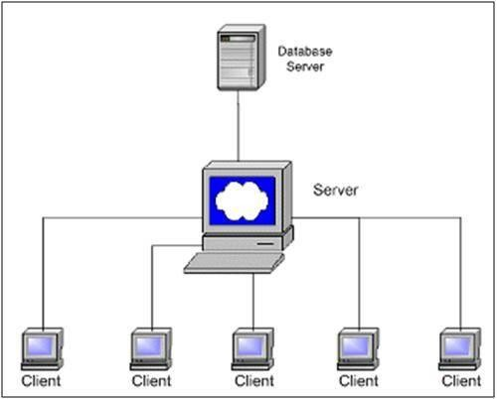

# FIG-1 Client-Server Architecture

First of all, if the user is a faculty, he/she can access the faculty login if he/she is already register in the system by admin or else, he/she will be redirected to a department page to choose the department, after that faculty will be redirected to a batch page if already batch are available in they can choose batch it navigate to subject page or batch is not available he/she can able to create.

After select the subject faculty can add student name, internal marks, semester marks and assignment marks, it automatically calculate direct course outcome.Faculty can edit course outcome of the particular course and enable in the indirect survey for the student. Now, student can take the indirect survey. This submitted values are taken to calculate over all course outcome attainment,  
 For each course faculty have to map its course outcome to the program outcome .This mapping used to calculate direct PO attainment, the indirect program outcome to calculate getting survey from parents and alumni student

# CHAPTER – 6 IMPLEMENTATION OF THE SYSTEM

* 1. **STEPS**
     1. Install the Xampp software which contain the required tomcat server and the MySQL database to store, modifying and retrieving date.
     2. Make a plan about the web page and the database connectivity
     3. The after successfully installing the tomcat install the JDK to make the tomcat perform well.
     4. Then in the ROOT folder of the tomcat create a folder and create JSP file those files should be connected with database using JBDC method
     5. In case of a Servlet file import the necessary packages and compile it and provide it with the required URL in the .XML file and restart the file
     6. Create necessary tables in the MySQL database and make sure that the proper connections with the database have been achieved
     7. Then completing the above steps check for the web contains and test the wed service
     8. The Deploy the web page and make sure the proper working of the web page

# SOFTWARE IMPLEMENTATION

**6.2.1 XAMPP APP**

HTTP Server, MariaDB database, and interpreters for scripts written in the PHP and Perl programming languages. Since most actual web server deployments use the same components as XAMPP, it makes transitioning from a local test server to a live server possible.XAMPP's ease of deployment means a WAMP or LAMP stack can be installed quickly and simply on an operating system by a developer, with the advantage that common add-in applications such as WordPress and Joomla! can also be installed with similar ease using Bitnami.Though it is a heavy app for most of the operating systems even when owing to its less size it takes a load on the processor speed. XAMPP is regularly updated to the latest releases of Apache, MariaDB, PHP and Perl. It also comes with a number of other modules including OpenSSL, phpMyAdmin, MediaWiki, Joomla, WordPress and more.Self- contained, multiple instances of XAMPP can exist on a single computer, and any given instance can be copied from one computer to another.XAMPP is offered in both a full and a standard version.

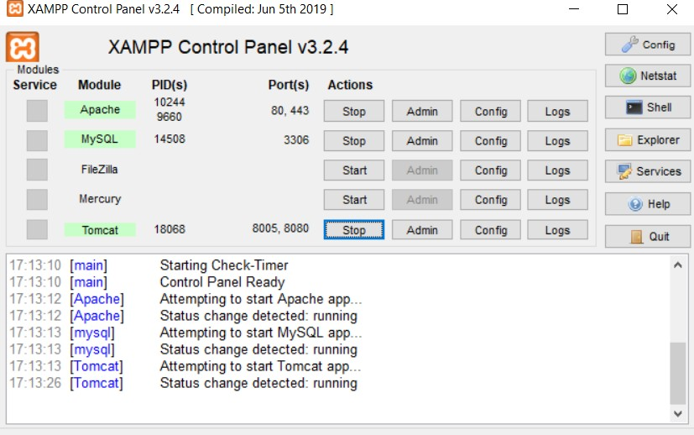

# FIG-2 XAMPP CONTROL PANEL

**CHAPTER – 7**

# DESIGN AND IMPLEMENTATION

* 1. **Product features**

The major features of the are listed below.

* + - Unauthorized access is prevented because only authorized or registered user can only process data and access resources
    - Also, the users request without login in are also prevented from accessing the data
    - And even a authorized user can’t to view other class marksheets if he have not asssigned to any subject for the semester to the class.

By achieving the above features Responsiveness and hence outcome of the system features increases.

# Modules

There are two different modules present in the system each module will have different functionalities to be performed. The different modules are as follows.

# Admin:

The admin has the role of registering faculties with their email and password details.He can able to edit department details and subject details.He can able to view all the marksheets and attainment result.But he can’t edit them.

# Faculty:

The role of the faculty is to create a new batch by providing the batch name and add students in the batch can able to drop the class that he/she have create but can’t able to delete the batch created by another faculty. In a batch faculty have the right to add semester subjects. They can also able to view other class marksheets.He can edit and enter students mark in the respective marksheets.

# Student:

The role of the student is they can give their feedback for each course in a survey form. For each course outcome their given with three option satisfy,highly-satisfy and not-satisfy. Based on their submitting indirect will be calculate.

# Parents and Alumni :

After end of the program collection feedback form the parents and alumni.Submitting values are calculated for indirect course outcomes.

# Database

In this back end we are using the MySQL database for storing and the retrieval of data and there are two main tables 1.student batches and 2.faculty. If the registered user is a faculty details will be stored in the faculty table.For each new batches a new database will automatically created.

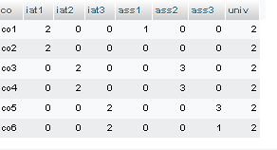

# FIG-3 MARK TABLE

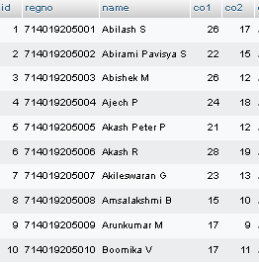

# FIG-4 STUDENT TABLE

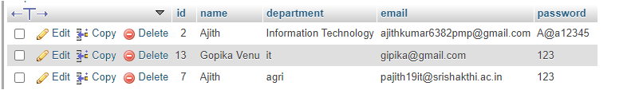

**FIG-5 FACULTY TABLE**

Then if the faculty Create a new batch the batch name will be saved in another table and it will also create a new table as well as new database.

# CHAPTER – 8

**CALCULATING PROCESS**

**Course outcome Attainment Evaluation Process**

The process used to evaluate the course outcome attainment is explained in the figure below

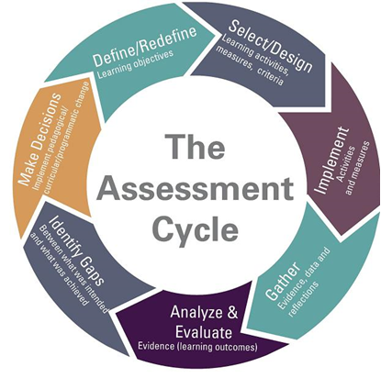

**FIG-6 ASSESSMENT CYCLE**

1. **Select / Define Course Outcome**

* Every course will have common, core expectations for student learning.
* These expectations are the most important things a student who passes the course will take

away from any section of the course.

* Every course coordinator will define 5 to 6 course outcomes for every course and the course

outcomes are validated and approved by the Program Assessment Committee.

* Framing the course outcomes is pictured as follows

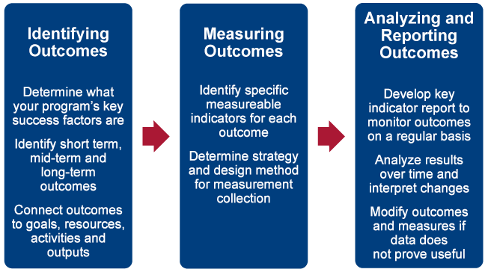

**FIG-7 DEFINE COURSE OUTCOME**

1. **Activities and Measures - Assessment Plan**

The methodology of assessment of every course outcome is planned at the beginning of the course. The different methodology of assessment includes but not limited to

* Internal Assessment Test
* Quiz
* Seminar
* Assignment
* Project
* Tutorial

The course coordinator prepares a detailed plan specifying the methodology used for assessment.The Program Assessment Committee and Head of the Department will approve the assessment plan submitted.

1. **Gathering Evidence data and reflections- Assessment**

The faculty handling the subject will assess the students’ skills and learning ability by using the assessment tools and methodologies

1. **Analyze and Evaluate**

The results of attainment of course outcome are analyzed and the delivery methodology, content, etc are improved in order to provide a quality education.

**Assessment Methodology:**

The course outcomes are evaluated based on the direct and indirect Assessment methods. The direct assessment method uses the following evaluative components.

**(a) The Internal Assessment Test**

Internal Assessment Tests(IAT) are conducted for fifty marks for three times in the duration of the course. The questions in the IAT are set based on the bloom’s taxonomy to evaluate the specific course outcomes.

**(b) Assignments/ Projects /Presentation, etc**

Apart from the IATs, the faculty handling the course will evaluate the course outcomes through evaluating the students’ performances in the assignments, projects, presentation, etc. The faculty decides the evaluative component based on the nature of the subject.

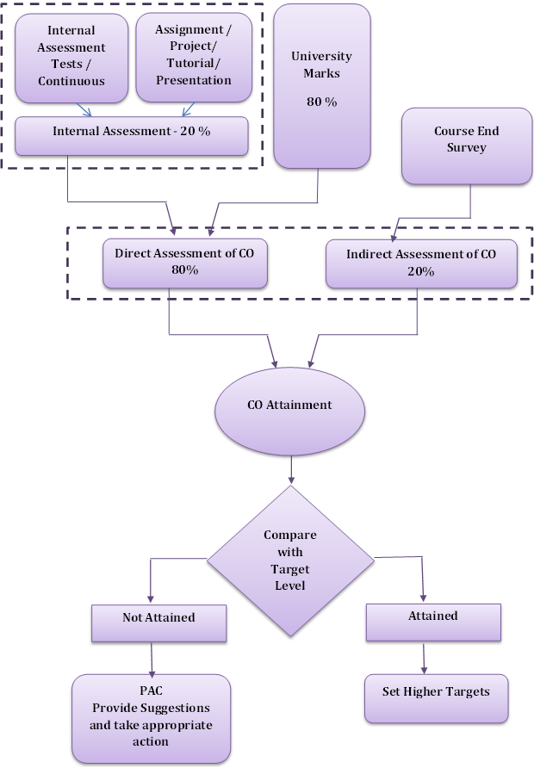

**FIG-8 FINAL CO ATTAINMENT CALCULATION**

**(c)End Semester Exam**

Since the college is an affiliated college, the end semester exam is conducted by the University for Hundred Marks. The attainment levels are set and the attainment level is calculated individually for all the IATs, Assignments/Projects/ Presentations and for the university exam. The indirect assessment of the course outcome is done through the survey which is taken at the end of the course.

**Attainment Level:**

The attainment levels are set considering the average performance level.

* **Attainment Level 1:** 60% students scoring more than average percentage marks in evaluative component
* **Attainment Level 2:** 70 % students scoring more than average percentage marks in evaluative component
* **Attainment Level 3:** 80% students scoring more than average percentage marks in university or set attainment level in final examination.

**Course Outcome Attainment:**

The attainment level is calculated as follows.

* 80% weightage is given to the direct assessment and 20% weightage is given to the indirect assessment
* In direct assessment 80% weightage is given to the end semester examination and 20% weightage is given to internal assessment.
* The direct assessment formula is given as follows,

**Direct Assessment=(70% of university level)+(20% of internal level)+(10 % of assignment)**

* The 20 % of indirect assessment is taken from the course end survey.

**Attainment of Program Outcomes and Program Specific Outcomes Process**

* Outcomes assessment is the process of collecting evidence that indicates the extent to which the program achieves its intentions.
* Assessment tools are categorized into direct and indirect methods to assess the program educational objectives, program outcomes and course outcomes. And tools are framed on the basis of the Constructive Alignment for the Outcome Based Learning.

**DIRECT ASSESSMENT**

The assessment tools are:

* Internal Assessment Test
* Assignments/ Group Assignments
* Continuous Lab Assessment
* Laboratory Internal Assessment Test
* Technical Seminars
* Project Assessment
* Semester End Lab Examination
* Semester End Theory Examination

**INDIRECT ASSESSMENT**

* **Program Exit Survey**

The program exit survey identifies twelve broad learning outcomes related to graduate education and asks graduates to indicate the level of preparation provided by their graduate program. This type of survey can also point to areas in which the institution should invest more or less resources to enhance a student's learning and development experience.

* **Alumni Surveys**

The Alumni Survey is designed to give graduates an opportunity to reflect upon their years after graduation. This information is used to improve the college experience for future students by identifying strengths in our programs as well as areas that need further development. The survey includes issues relating to satisfaction regarding academic programs, intellectual and personal growth, student services, and preparation for a career.

* **Employer Surveys**

Provide information about the curriculum, programs and course outcomes, on-the-job field-specific information about the application and value of the skills that the program offers. It helps to determine if their graduates have the necessary job skills and if there are other skills that employers particularly value that graduates are not acquiring in the program

**DIRECT METHODS**

Display the student’s knowledge and skills from their performance in the continuous assessment tests, end-semester examinations, presentations, and classroom assignments etc. These methods provide a sampling of what students know and/or can do and provide strong evidence of student learning.

**INDIRECT METHODS**

Such as surveys and interviews, ask the stakeholders to reflect on the student's learning. They assess opinions or thoughts about the graduate’s knowledge or skills. Indirect measures can provide information about graduate’s perception of their learning and how different stakeholders value this learning. The following table summarizes the various assessment tools.

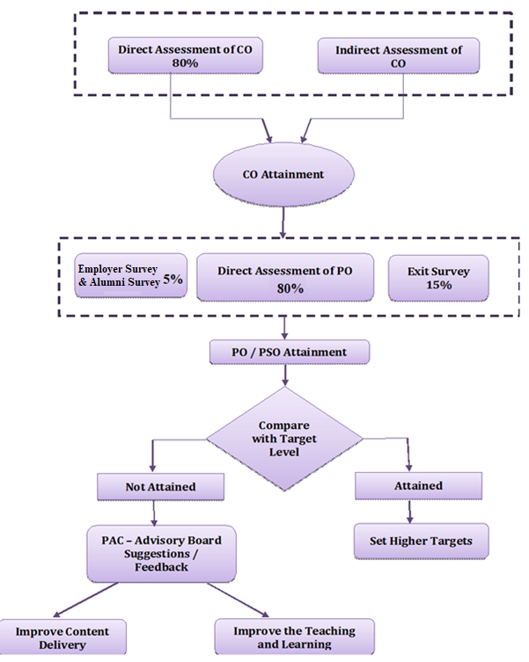

**FIG-9 FINAL PO ATTAINMENT CALCULATION**

**EVALUATION OF EACH PO AND PSO**

* Program outcome attainment levels are set by the program assessment committee for all POs and PSOs. The PO and PSO matrix indicate direct and indirect attainment levels.
* The average across all the courses addressing PO/PSO gives the direct attainment level of PO/PSO. The student exit surveys, employers’ survey, co-curricular activities, extracurricular activities and many factors give the indirect attainment level of PO/PSO.
* PO attainment level will be based on the direct and indirect assessment level.
* Overall attainment level is calculated considering 80% weight age to the direct assessment and 20% Weightage to the indirect assessment.

**DIRECT ASSESSMENT**

* Attainment levels will be summation of course attainment levels divided by no. of courses.

**INDIRECT ASSESSMENT**

* Employer survey and Student exit survey analysis is customized to an average values as per the level 1, 2, 3
* PO attainment level will be 80% of direct assessment + 20% of indirect assessment in which 15% Weight-age is given to student exit survey and 5% Weight-age is given to employer survey. Similar procedure is followed for PSO.

The program assessment committee will assess the PO/PSO attainment values and will suggest appropriate actions for continuous improvement.

# CHAPTER – 9 RESULT

We have developed a web page which contains few modules which is admin and faculty It can handle all details about a college mark sheet system. The details include faculty details, subject details, student personnel details, academic details, exam details. In this we can implement a facility that a faculty can be able to create a new batch of students and other faculties those who have mapped to handle subjects, can able to access and enter marks of that batch students.

The admin has the role of registering faculties with their email and password details.He can able to edit department details and subject details.He can able to view all the marksheets and attainment result.But he can’t edit them.

The role of the faculty is to create a new batch by providing the batch name and add students in the batch can able to drop the class that he/she have create but can’t able to delete the batch created by another faculty. In a batch faculty have the right to add semester subjects. They can also able to view other class marksheets.He can edit and enter students mark in the respective marksheets.The role of the student is they can give their feedback for each course in a survey form. Based on their submitting indirect will be calculate.After end of the program collection feedback form the parents and alumni.Submitting values are calculated for indirect course outcomes.

.

# CHAPTER – 10 CONCLUSION

The CO-PO attainment calculation system is a set of tools that enables the teaching staff to create student batch and enter their exam scores on the Web in order to calculate attainment. It can handle all details about a college marksheets system. The details include faculty details, subject details, student personnel details, academic details, exam details. In this we can implement a facility that a faculty can be able to create a new batch of students and other faculties those who have mapped to handle subjects, can able to access and enter marks of that batch students.

# FUTURE ENCHANCEMENT

Many more features can be added which are given as follows.

* + - To implement a feature for the faculty to view only his/her respective subjects alone..
    - Feature to take print out of final attainment result.
    - Updating features for the existing batch.

# CHAPTER – 11 REFERENCES

<https://www.vrsiddhartha.ac.in/co-po-attainment/>

<https://velalarengg.ac.in/governing/insight_co&po.php>

<https://www.vrsiddhartha.ac.in/co-po-attainment/#:~:text=Attainment%20of%20Outcomes%3A&text=Course%20Outcomes%20(COs)%20are%20defined,attainment%20of%20POs%20and%20PSOs.>

**APPENDICES**

# DEMO SCREEN

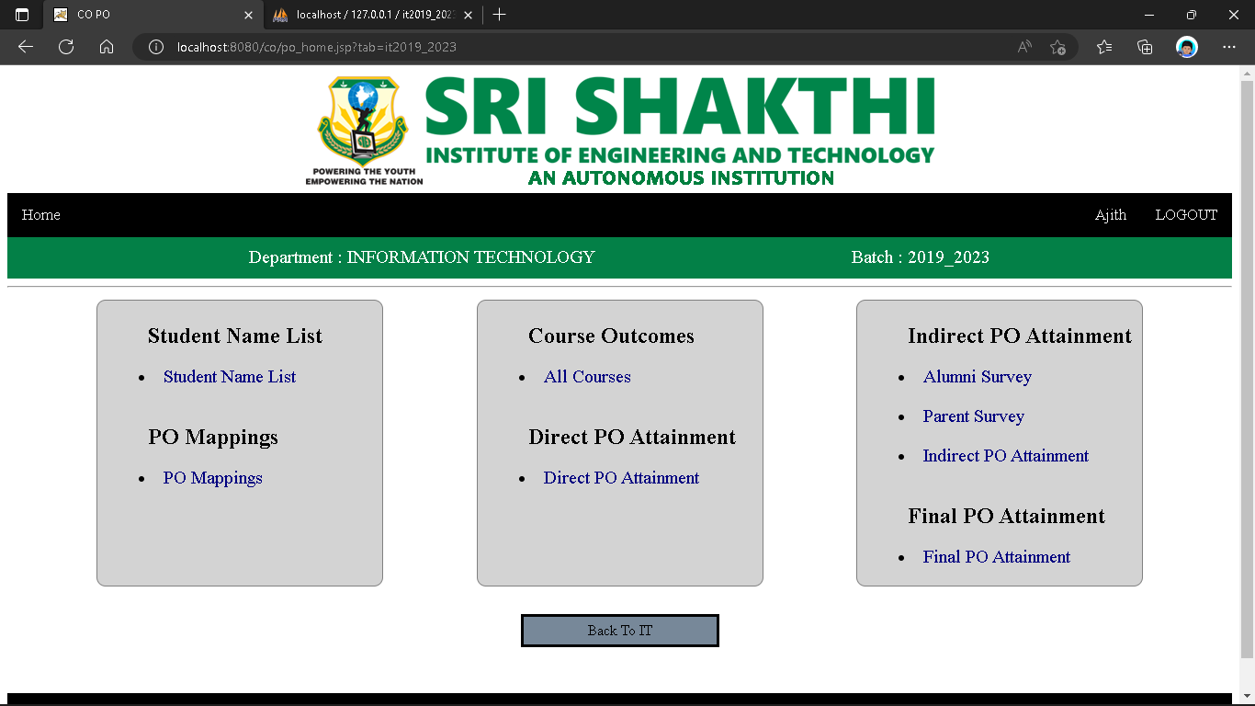

**FIG-10 PO HOME PAGE**

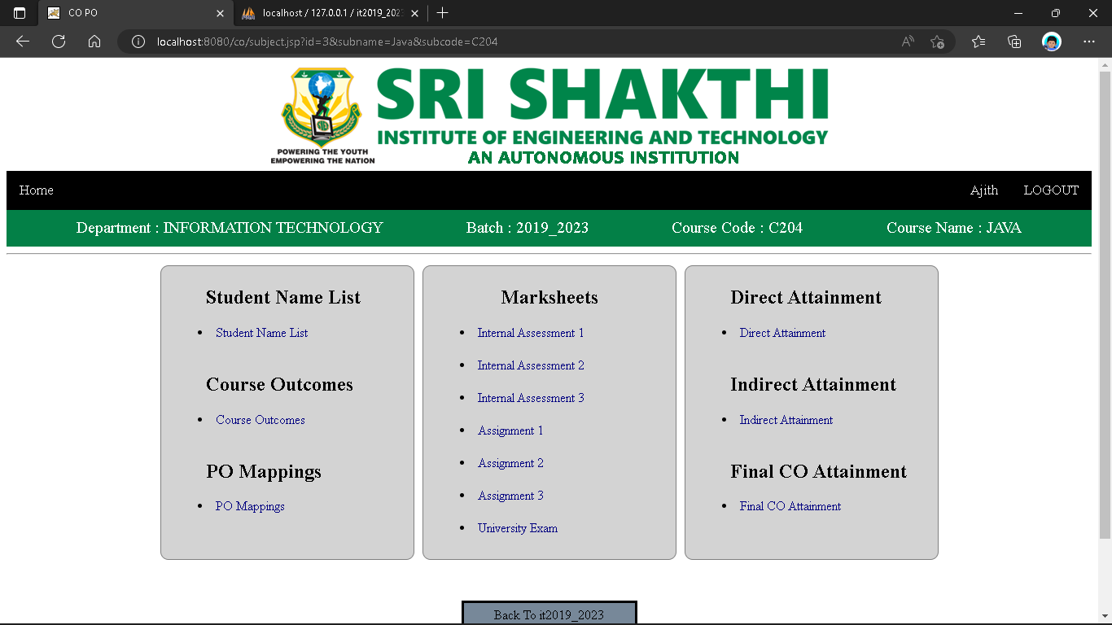

**FIG-11 SUBJECT HOME PAGE**

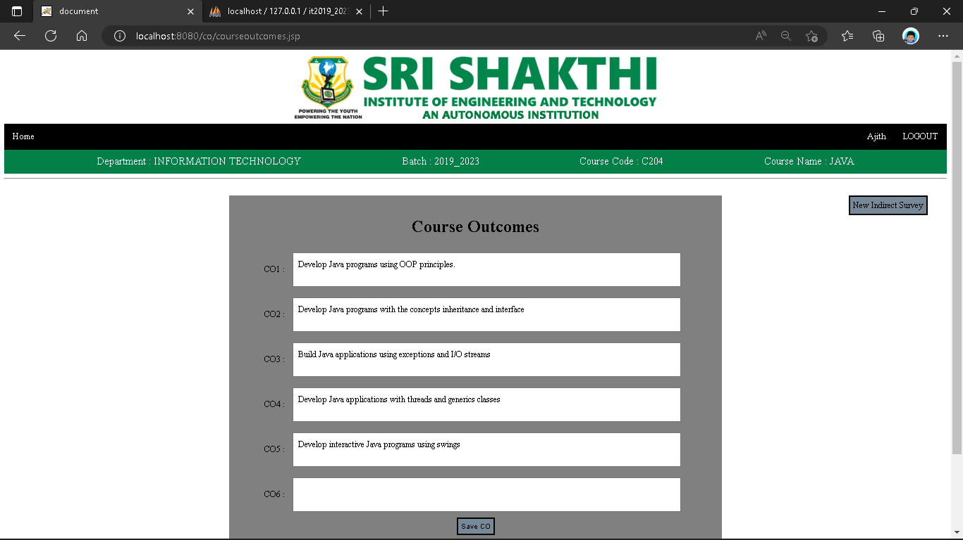

**FIG-12 COURSE OUTCOME PAGE**

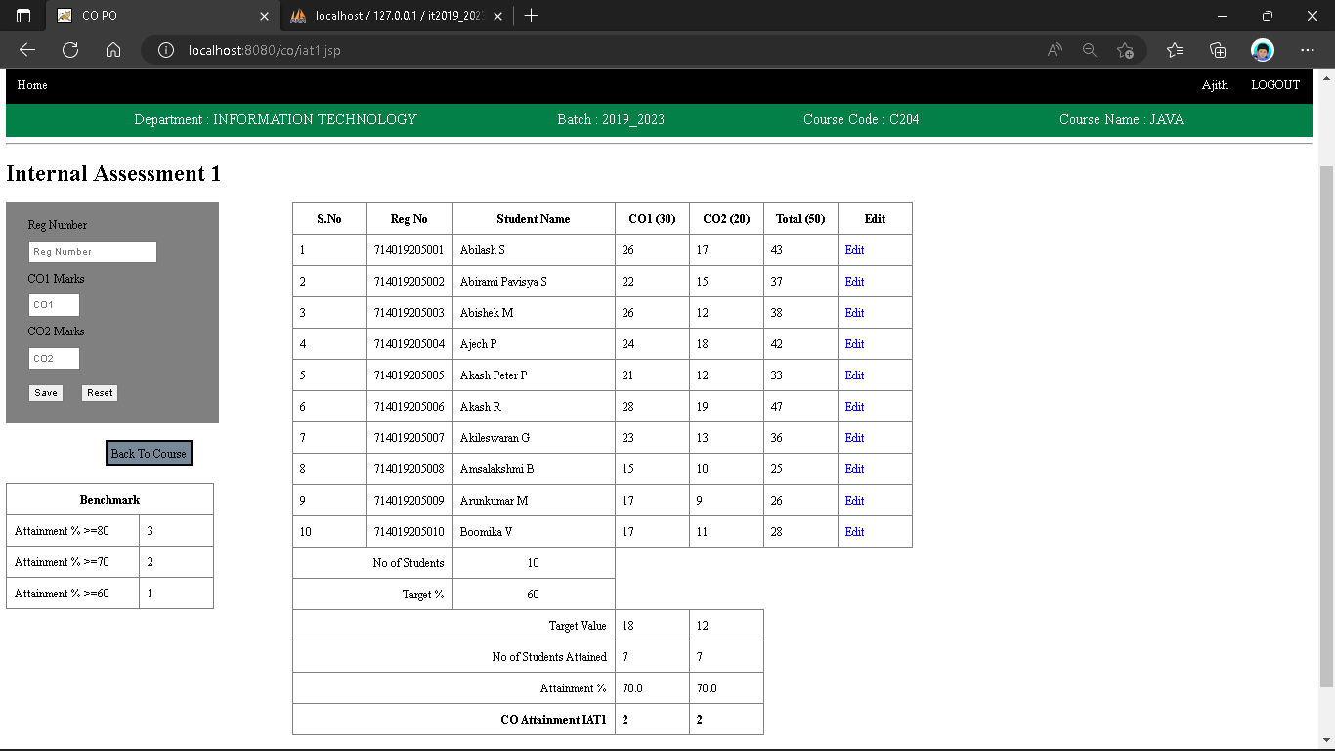

**FIG-13 INTERNAL MARK SHEETPAGE**

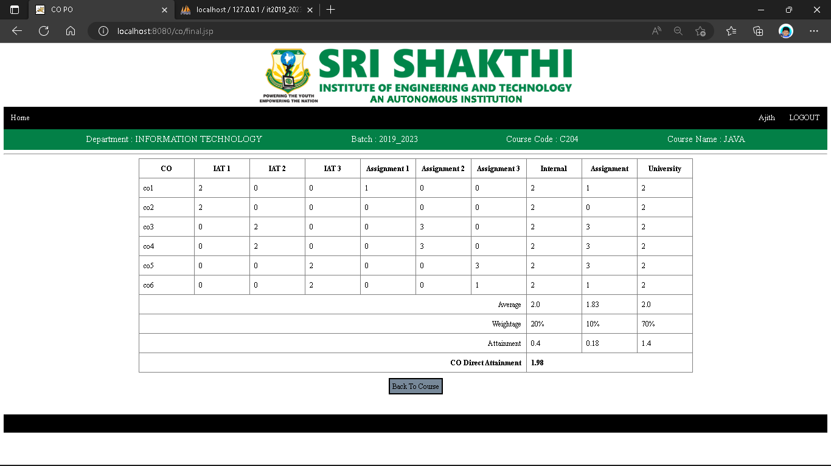

**FIG-14 FINAL CO ATTAINMENT CALCULATION**